*A Project Report*

*on*

**Online Proctoring Using AI**

*carried out as part of the course CS1634 Submitted by*

***Hritik Dixit - 179301082***

***Vardan Agarwal - 179301222***

***VI-CSE***

*in partial fulfilment for the award of the degree*

*of*

**BACHELOR OF TECHNOLOGY**

In

**Computer Science & Engineering**



**Department of Computer Science & Engineering,**

**School of Computing and IT,**

**Manipal University Jaipur,**

***June, 2020***

CERTIFICATE

Date: 14th June, 2020

This is to certify that the project titled **Online Proctoring Using** AI is a record of the bonafide work done by **Vardan Agarwal** (179301222) and **Hritik Dixit** (179301082) submitted in partial fulfilment of the requirements for the award of the Degree of Bachelor of Technology (B.Tech) in Computer Science and Engineering of Manipal University Jaipur, during the academic year 2019-20.

**Mr. Vijender Singh**

Associate Professor

Dept. of Computer Science Engineering

Manipal University Jaipur

**Abstract**

With the advances in innovation, society is turning out to be increasingly computerized. Huge open online courses and remote types of training keeps on expanding in fame and reach. The widespread effect of COVID-19 has exponentially increased the requirements for such courses as well. The capacity to effectively delegate remote online assessments is a significant restricting element to the versatility of this next stage in education. Presently, human proctoring is the most common approach of evaluation, by either requiring the test taker to visit an examination centre, or by monitoring them visually and acoustically during exams via a webcam. However, such methods are labour intensive and costly. In this project, we present a multimedia solution to semi-automate proctoring without the use of any external hardware other than the webcam and microphone of the student’s computer. The system constantly monitors and evaluates the user based on: gaze detection, lip movement, the number of people in the room, mobile phone detection, and add whatever required here. If any discrepancies are found it is reported to the proctor who can verify it and take the necessary action. Extensive experimental results demonstrate the accuracy, robustness, and efficiency of our online exam proctoring system and it helps a single proctor to monitor multiple test-takers at once.

**List of Tables**

**List of Figures**

1. **Introduction**

The online learning industry has been growing by leaps and bounds in the last year and that growth is catapulted by the ongoing global pandemic. With the restrictions on gathering of groups and the shutting down on schools, everyone has had to adopt an online approach. This has consequently lead to the increase in popularity of applications like Microsoft Teams, Zoom, etc. to provide quality education.

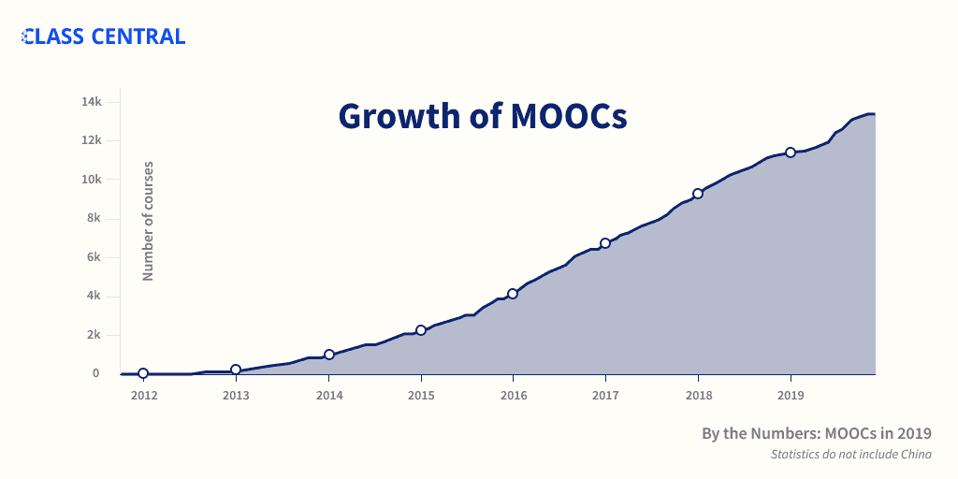

Figure 1: Rise of MOOCs

Evaluating students still remains an ambivalent task. Assessing a single student at a time is very tedious and time taking task and if conditions like the ones due to the pandemic are going to become the norm then a solution needs to be found out. Having a common assignment, the solution which is used in most remote learning applications, has several drawbacks and plagiarism is a common sight in them.

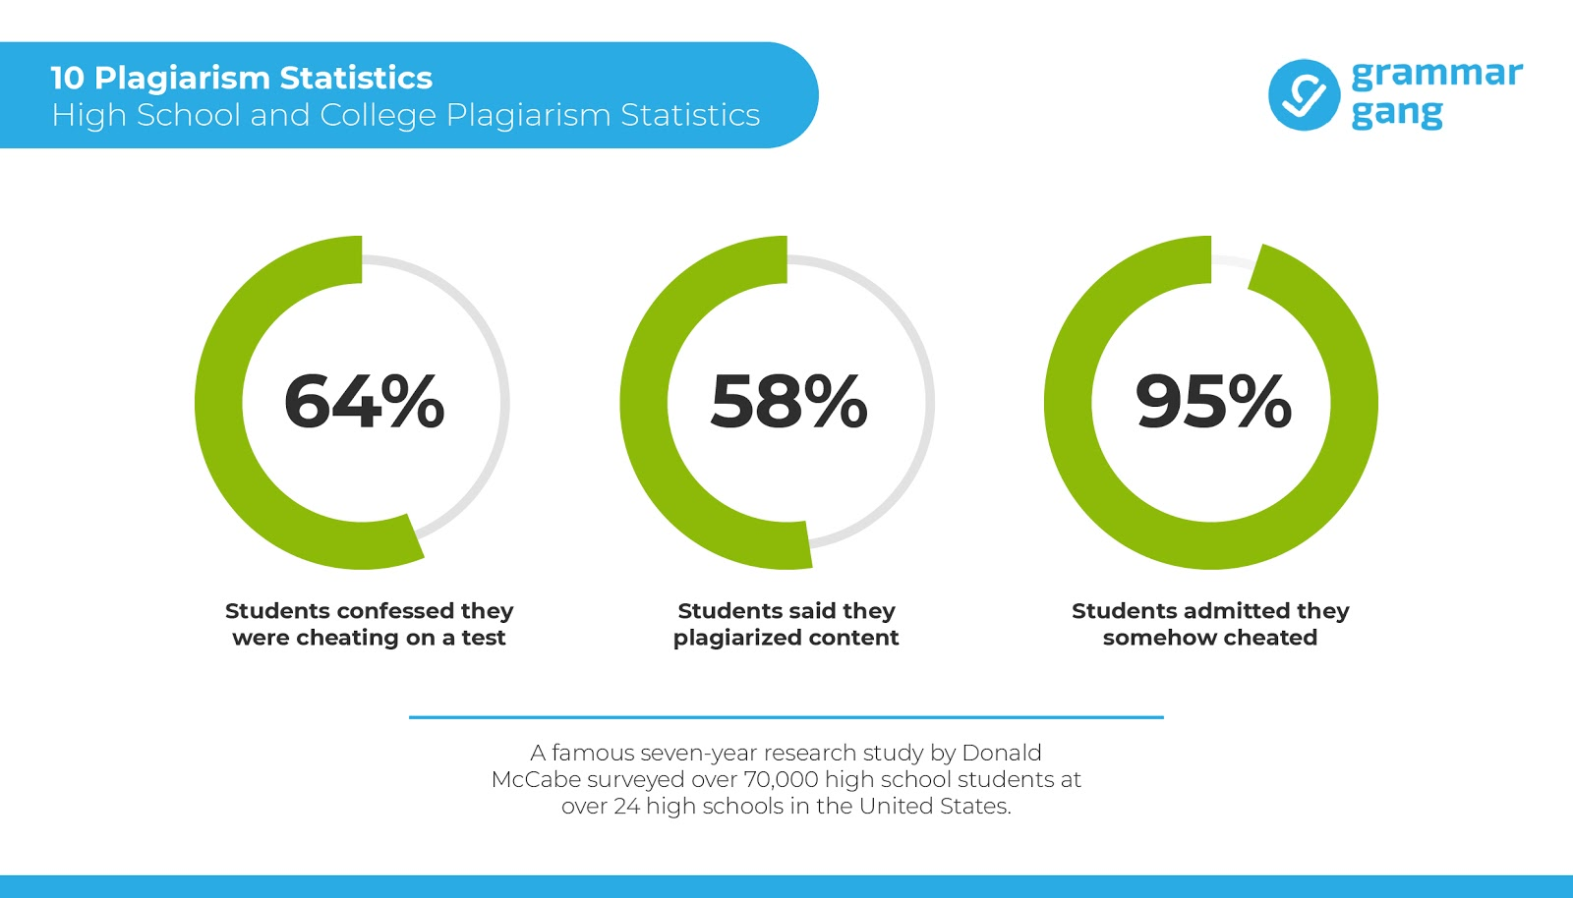

Figure 2: Plagiarism Statistics

So the only way forward is to have an automated proctoring system which can monitor students and prevent cheating. We have devised a system using deep learning and artificial intelligence techniques which monitors users continuously based on both visual and audio clues. The visual clues include monitoring the student’s gaze to see where he is looking, monitoring the mouth to check if he or she is trying to communicate, count the number of people in webcam feed and find any mobile phones. The audio clues include add here. This will ensure that teachers are not overburdened and can manage the whole class at a time.

Combining these solutions with a secure test taking application can help resolve the education industry is going to face in the near future.

1. **Requirement Analysis**
2. **Functional Requirements:**